Regime-conditioned correlation: EURUSD and USDJPY
Method 11 / daily log returns / shared FX turbulence regimes / Alpari D1 full available history

Study setup
Logical pair: EURUSD , USDJPY
Broker symbols: EURUSD_i , USDJPY_i
Snapshot: 2026-11-03_majors_alpari_D1
Timeframe: D1
Matched return window: 1999-01-06 to 2026-11-02 (UTC bar dates)
Matched return count n: 7127
Labeled rows n: 6855
Dropped unfinished last bar dated 2026-11-03 UTC after a tick-volume check against the prior complete day.
State rule: turb = equal-weight mean of eight |log returns|; RV = mean of prior 20 turb days; after 252 past RV values, stress if RV > 75th percentile of those past values, else quiet
Complete matched rows (Excel): EURUSD-USDJPY_Regime_D1.xlsx
Complete matched rows (HTML table): EURUSD-USDJPY_Regime_D1_data.html

Method carried forward
Regime-conditioned correlation splits matched daily log returns of close, ln(close_t / close_t-1), into quiet and stress states defined from a shared FX turbulence rule fixed before any pair rho is computed. Quotes are not inverted. On dates where all eight majors have a log return, turb_t is the equal-weight mean of the eight absolute log returns. RV_t is the mean of turb over the previous 20 completed days (t-20 through t-1); day t is not in the label. After 252 past RV values exist, S_t = stress when RV_t exceeds the 75th percentile of those past values, otherwise quiet. Earlier days stay unlabeled and are dropped from both rhos. One S_t series is applied to every pair. rho_quiet and rho_stress are Pearson correlations on their own subsamples; their mean is not a headline. Full-sample Pearson r on labeled rows only is a side check. This is not a cause, lead, or trading signal.

Results
rho_quiet: -0.340338 (n=5092)
Quiet 95% Fisher interval: [-0.364399, -0.315822]
rho_stress: -0.247157 (n=1763)
Stress 95% Fisher interval: [-0.290490, -0.202813]
Pearson r on labeled rows: -0.304930
rho_stress minus rho_quiet: 0.093180

Conclusion
On the labeled subsample for EURUSD and USDJPY, rho_quiet is -0.3403 (n_quiet=5092, weak) and rho_stress is -0.2472 (n_stress=1763, weak). stress minus quiet = 0.0932. Pearson r on all labeled rows is -0.3049. Regime rhos are not averaged into a headline. This does not establish cause, lead-lag, or a lasting trading rule.

Charts
Daily closes
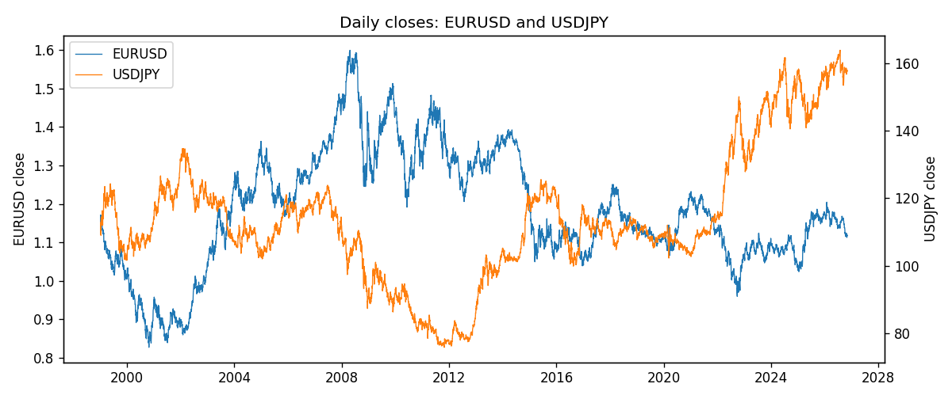
Log returns with stress days
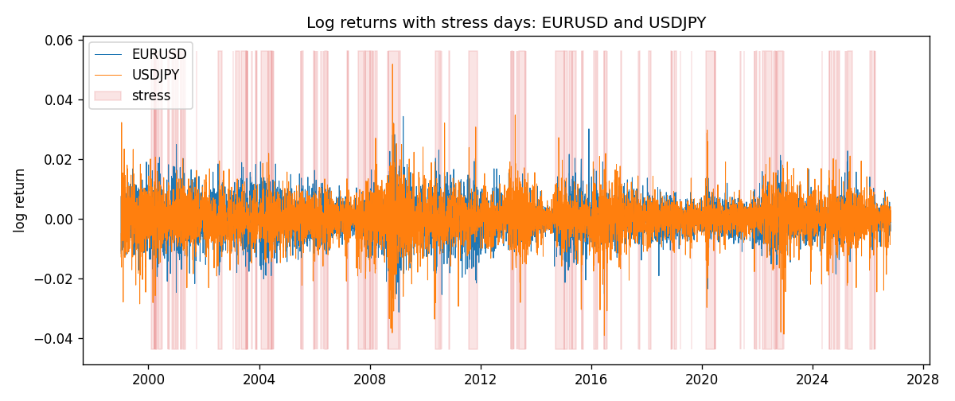
Scatter colored by regime
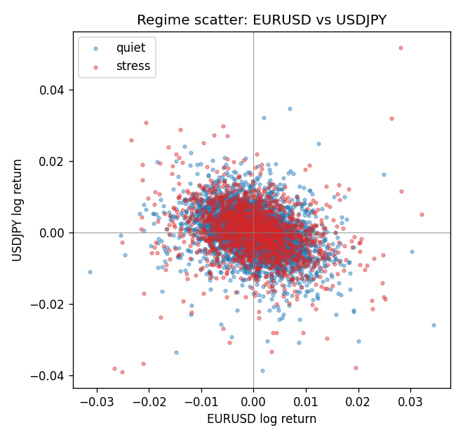

Data report
Every matched row that entered the regime analysis is stored in the sibling Excel workbook named EURUSD-USDJPY_Regime_D1.xlsx. That file is the complete data archive for redrawing charts. Embedding all rows as a Word table is impractical at this length; the Word file holds the column list, column summaries, and the first and last 15 matched rows.
Columns: time, EURUSD_open, USDJPY_open, EURUSD_high, USDJPY_high, EURUSD_low, USDJPY_low, EURUSD_close, USDJPY_close, EURUSD_tick_volume, USDJPY_tick_volume, EURUSD_spread, USDJPY_spread, EURUSD_real_volume, USDJPY_real_volume, EURUSD_log_return, USDJPY_log_return, turb, rv, state
Column summaries (matched calculation rows)
column | count | mean | std | min | 25% | 50% | 75% | max
EURUSD_open | 7127 | 1.1819407 | 0.15065555 | 0.8272 | 1.086455 | 1.16615 | 1.294285 | 1.5995
USDJPY_open | 7127 | 113.80058 | 19.291864 | 75.693 | 104.3005 | 110.961 | 120.7475 | 163.824
EURUSD_high | 7127 | 1.1870746 | 0.15125674 | 0.8326 | 1.09055 | 1.17128 | 1.29974 | 1.6038
USDJPY_high | 7127 | 114.29785 | 19.353625 | 76.001 | 104.822 | 111.42 | 121.29 | 163.978
EURUSD_low | 7127 | 1.1769341 | 0.14996546 | 0.8227 | 1.082375 | 1.16257 | 1.288915 | 1.5865
USDJPY_low | 7127 | 113.2782 | 19.219415 | 75.402 | 103.814 | 110.515 | 120.2 | 163.628
EURUSD_close | 7127 | 1.1819858 | 0.15061943 | 0.8267 | 1.08652 | 1.16617 | 1.294345 | 1.5997
USDJPY_close | 7127 | 113.81424 | 19.307121 | 75.811 | 104.298 | 110.98 | 120.725 | 163.851
EURUSD_tick_volume | 7127 | 103994.86 | 174033.72 | 469 | 9542.5 | 53148 | 99923.5 | 1471626
USDJPY_tick_volume | 7127 | 107141.8 | 179947.68 | 197 | 10056 | 53577 | 93233 | 1803508
EURUSD_spread | 7127 | 19.176652 | 16.472988 | 0 | 8 | 12 | 20 | 50
USDJPY_spread | 7127 | 20.095973 | 17.5534 | 0 | 6 | 11 | 30 | 50
EURUSD_real_volume | 7127 | 4.0656436e+10 | 1.6756658e+11 | 0 | 0 | 0 | 0 | 3.6149665e+12
USDJPY_real_volume | 7127 | 3.5056645e+10 | 1.6155964e+11 | 0 | 0 | 0 | 0 | 3.8834203e+12
EURUSD_log_return | 7127 | -3.8e-07 | 0.00580028 | -0.03123819 | -0.00324243 | 8.31e-06 | 0.00325629 | 0.03433183
USDJPY_log_return | 7127 | 5.336e-05 | 0.00621278 | -0.03908203 | -0.00319557 | 0.00013026 | 0.00340928 | 0.05184024
turb | 7127 | 0.00445959 | 0.00282918 | 0.00037963 | 0.00261198 | 0.0037799 | 0.00552711 | 0.03459225
rv | 7107 | 0.00446101 | 0.00154844 | 0.00196224 | 0.00349842 | 0.00419785 | 0.00504672 | 0.01681284
First 15 matched rows (selected columns)
time | EURUSD_close | USDJPY_close | EURUSD_log_return | USDJPY_log_return | turb | rv | state
1999-01-06 | 1.1623 | 112.77 | -0.011547966 | 0.0075660159 | 0.0076050103 | nan
1999-01-07 | 1.1712 | 111.33 | 0.0076280636 | -0.012851583 | 0.0074649616 | nan
1999-01-08 | 1.1585 | 110.8 | -0.010902799 | -0.0047719894 | 0.0050591228 | nan
1999-01-11 | 1.1503 | 109.02 | -0.007103287 | -0.016195423 | 0.0070726231 | nan
1999-01-12 | 1.1555 | 112.6 | 0.0045103728 | 0.032310364 | 0.0086383872 | nan
1999-01-13 | 1.1681 | 113.52 | 0.010845346 | 0.0081373171 | 0.0086507097 | nan
1999-01-14 | 1.1681 | 113.52 | 0 | 0 | 0.0020203601 | nan
1999-01-15 | 1.1563 | 114.15 | -0.010153245 | 0.0055343401 | 0.0070767347 | nan
1999-01-18 | 1.1605 | 114.16 | 0.0036256946 | 8.7600193e-05 | 0.0015765158 | nan
1999-01-19 | 1.1603 | 113.52 | -0.00017235436 | -0.0056219403 | 0.0026247838 | nan
1999-01-20 | 1.1566 | 112.91 | -0.0031939256 | -0.0053879917 | 0.004250517 | nan
1999-01-21 | 1.1601 | 113.87 | 0.0030215416 | 0.0084664056 | 0.0035377047 | nan
1999-01-22 | 1.1587 | 114.56 | -0.0012075213 | 0.0060412564 | 0.0047991939 | nan
1999-01-25 | 1.1552 | 113.72 | -0.0030251979 | -0.0073594164 | 0.0034814433 | nan
1999-01-26 | 1.1562 | 113.86 | 0.00086527651 | 0.0012303367 | 0.0016787089 | nan
Last 15 matched rows (selected columns)
time | EURUSD_close | USDJPY_close | EURUSD_log_return | USDJPY_log_return | turb | rv | state
2026-10-13 | 1.11965 | 158.305 | 0.0037402957 | -0.0018932826 | 0.0031058536 | 0.0026375679 | quiet
2026-10-14 | 1.11545 | 158.317 | -0.0037582255 | 7.5800166e-05 | 0.0024477448 | 0.0026868646 | quiet
2026-10-15 | 1.12172 | 158.024 | 0.0056053107 | -0.0018524319 | 0.005079354 | 0.0025028822 | quiet
2026-10-16 | 1.12371 | 157.964 | 0.0017724895 | -0.00037976126 | 0.0030181963 | 0.0026570677 | quiet
2026-10-19 | 1.12086 | 158.517 | -0.0025394633 | 0.0034946841 | 0.002606264 | 0.002690775 | quiet
2026-10-20 | 1.12354 | 158.16 | 0.0023881672 | -0.0022546642 | 0.0034178126 | 0.0027332085 | quiet
2026-10-21 | 1.12318 | 158.108 | -0.00032046717 | -0.00032883504 | 0.0014061961 | 0.0028442121 | quiet
2026-10-22 | 1.12139 | 156.755 | -0.0015949606 | -0.0085942669 | 0.0030365905 | 0.0025988726 | quiet
2026-10-23 | 1.11989 | 156.81 | -0.001338521 | 0.00035080446 | 0.0019723563 | 0.0026359185 | quiet
2026-10-26 | 1.11735 | 157.458 | -0.0022706559 | 0.0041238746 | 0.0021200635 | 0.0026261912 | quiet
2026-10-27 | 1.11272 | 157.894 | -0.004152342 | 0.0027651658 | 0.0022946332 | 0.0026471726 | quiet
2026-10-28 | 1.1152 | 157.743 | 0.0022262927 | -0.00095679538 | 0.0030127531 | 0.0026549813 | quiet
2026-10-29 | 1.11772 | 157.683 | 0.0022571351 | -0.00038043789 | 0.0021367288 | 0.0026721044 | quiet
2026-10-30 | 1.11644 | 157.516 | -0.0011458446 | -0.0010596481 | 0.0011153176 | 0.0025721151 | quiet
2026-11-02 | 1.11881 | 157.933 | 0.002120569 | 0.0026438521 | 0.0027546138 | 0.0025153762 | quiet

